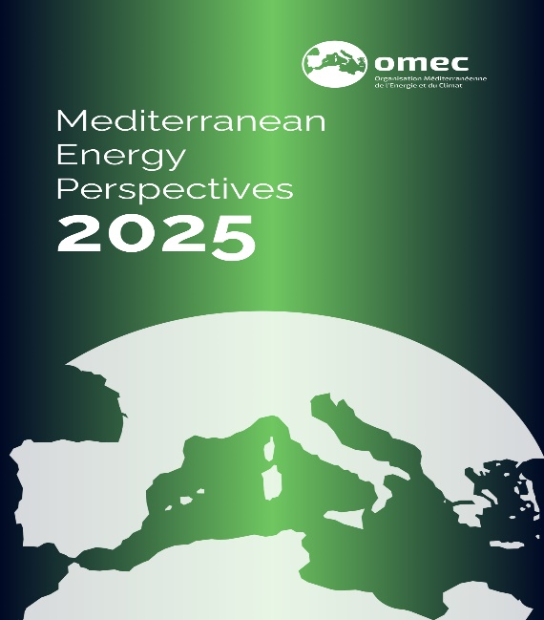
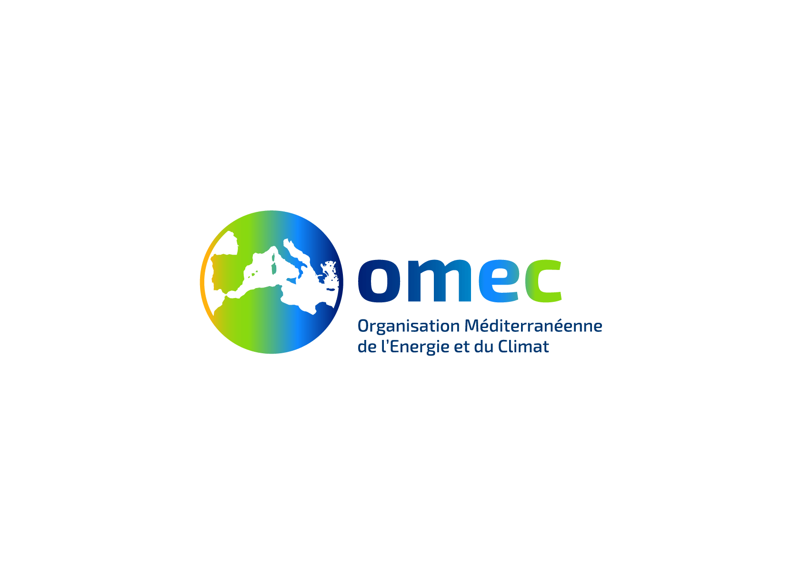

ORDER FORM

OMEC
32Bis, Boulevard Haussmann
75009 Paris - France
Email order: omec@omec-med.org

Tel: + 33 (0) 170 169 120

Date:

Delivery Details (if your billing address differs from your delivery address, please advise us)
Name: Company:
Address:

Country: Post Code:
Phone: Fax:
Email:
The publication is delivered by express mail service, so please enter your phone number above
I would like to order the following publication:

PUBLICATION | QTY | Unit Price  VAT excl. | Special discount* | TOTAL
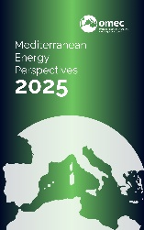  Mediterranean Energy Perspective 2025  - Hard Copy  - Electronic copy (pdf) |  | €150  €100 | €75  €50
VAT 5.5% (applicable for France only)
Hard copy postage (10 euros)
15 % Discount (for more than two publications ordered)
PROMO CODE 20%: PREORDER
(Valid until 30/04/2025)__________________
Total
*Special discount: for universities and non-profit organizations and for purchasers based in South Mediterranean countries.
Payment Mode (please tick)

Check (applicable for France only)
Bank Transfer (Please directly contact OMEC for details at omec@omec-med.org )
Please send an invoice together with the publication (please tick)
NB: Publication will be sent Only Upon Receipt of Payment

